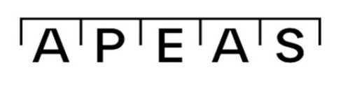
APEAS Part 3 Examination 2026/27
Artificial Intelligence (AI) Declaration Form
In accordance with the APEAS AI Policy you are required to declare what AI software you have used in your documentary submissions and for what purpose. Please therefore answer the following two questions for each of your submissions (to be included at the beginning of each submission)
Name:
APEAS number:
Submission: Practice Paper ☐
Experience Based Analysis ☐
Record / Certificate of Experience ☐
What, if any, AI tools were used in this component of the Part 3 Examination?
If you have entered information into the box above please state the purpose for which the AI was used in the box below.
Declaration
In signing this Form you confirm that your use of AI conforms with the requirements set out in the APEAS AI Policy.
Candidate Name:
Candidate Signature:
Date:

